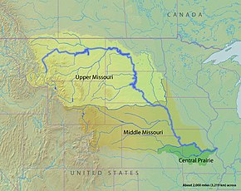
100th Meridian Initiative
Missouri River Basin AIS Team Meeting
November 28, 2023
9 am mountain to 1 pm mountain time
https://meet.goto.com/254166069

Agenda

9:00 am |  | Welcome
9:10 am | State Partner Updates  (8-10 min/each) | - Montana – Craig McLane, MT Fish Wildlife & Parks  - North Dakota – Ben Holen, ND Game and Fish  - South Dakota – Tanner Davis, SD Game, Fish and Parks  - Wyoming – Travis Beam, WY Game and Fish  - Colorado – Robert Walters, CO Parks and Wildlife  - Nebraska – Kris Stahr, NE Game and Parks  - Iowa – Kim Bogenschutz, IA Dept. of Natural Resources  - Kansas – Chris Steffen, KS Wildlife, Parks and Tourism  - Minnesota – Grace Loppnow, MN Dept. of Natural Resources  - Missouri – Angela Sokolowski, MO Dept. of Conservation
10:40 am | Invasive Carp Technical Committee Update | Neal Jackson, US Fish and Wildlife Service (invited)
11:00 am | Assessing human-mediated pathways for invasive carp spread to inform education and outreach activities | Kim Bogenschutz, IA Department of Natural Resources
11:20 am |  | BREAK
11:30 am | WRDA APC-WID Progress and Implementation | Jonas Grundman, US Army Corps of Engineers
11:50 am | Regional BOR Collaboration on WID | Jacob Bradford, Bureau of Reclamation
12:10 pm | Dreissenid eDNA collection and data sharing | Tom Woolf, MT Fish, Wildlife & Parks
12:30 pm | AIS Legislative Update | Stephen Phillips, Pacific States Marine Fisheries Commission
12:50 pm | Next Steps / Future Meetings | Open discussion
1:00 pm |  | Adjourn
MRB AIS Team Meeting
Please join my meeting from your computer, tablet or smartphone: https://meet.goto.com/254166069
You can also dial in using your phone.
Access Code: 254-166-069 | United States: +1 (646) 749-3122
Get the app now and be ready when your first meeting starts: https://meet.goto.com/install

